# amblem, simge, sembol, logo, ticari marka içeren bir resim Açıklama otomatik olarak oluşturuldu

**UNIVERSITY OF TURKISH AERONAUTICAL ASSOCIATION**

**ENGINEERING FACULTY**

**DEPARTMENT OF COMPUTER ENGINEERING**

**CENG 301 LAB Project**

**Project Title:**

Human Resources Management Application

**Project Member(s):**

Fevzi FİDAN

Hikmet ÇATAK

Ömer Faruk AZİLİ

**Project Advisor**

Ahmet Serkan KARATAŞ, Ayşe Beyza ÜNAL

**17.11.2024**

Table of Content

* 1. **Project Introduction  
     1.1 Project Overview**

Briefly describe the purpose and objectives of the database project.

**1.2 Project Team**

**Roles and Responsibilities:**

Fevzi FİDAN: Responsible for creating the user interface and ensuring its usability.

Hikmet Çatak,Ömer Faruk Azili: Responsible for designing and implementing the database.

Hikmet Çatak, Ömer Faruk Azili: Responsible for writing Python functions that will run in app.

**Project Scope**

Clearly define the scope of the database project, including its intended functionalities and limitations.

* 1. **Database Design  
     2.1 Introduction**

Provide an introduction to the database design, highlighting its purpose and significance in the context of the project.

**2.2 Entity-Relationship Diagram (ERD)**

metin, ekran görüntüsü, paralel, sayı, numara içeren bir resim

Açıklama otomatik olarak oluşturuldu

* 1. **Data Dictionary**

**Table:employees****:** Represents the employees in the company.  
  
**Columns:**

|  |  |
| --- | --- |
| **employee_id** | int AI PK |
| first_name | varchar(50) |
| last_name | varchar(50) |
| date_of_birth | date |
| gender | varchar(50) |
| job_title | varchar(50) |
| department | varchar(25) |
| salary | decimal(8,2) |
| hire_date | date |
| email | varchar(50) |
| phone_number | varchar(50) |
| password | varchar(50) |
| is_active | tinyint(1) |

**Table:email: :** Represents the email records that sent.  
  
**Columns:**

|  |  |
| --- | --- |
| **id** | int AI PK |
| email_title | varchar (255) |
| email_description | text |
| **from_emp_id** | int |
| **to_emp_id** | int |

**-****An employee can send and get multiple email (many to many)**

**-From_emp_id, to_****emp_id** in the **email** is a **foreign key** that references the **employee_id** column in the **employees** table.

**Table:employee_items:** Represents the assigned items to employees.  
  
**Columns:**

|  |  |
| --- | --- |
| **employee_id** | int |
| **item_id** | int |
| assignment_date | datetime |
| quantity | int |
| **assign_id** | int AI PK |

**-** **More than one item can be assigned to more than one employee based on quantity. (many to many)**

**-employee_id** in the **employee_items** is a **foreign key** that references the **employee_id** column in the **employees** table.

**Table:employee_leaves:-Ö**  
  
**Columns:**

|  |  |
| --- | --- |
| **leave_request_id** | int AI PK |
| **employee_id** | int |
| status_of_request | enum('Pending','Accepted','Rejected') |
| request_date | date |
| approved_by | int |
| answer_date | date |
| leave_type | enum('Annual Leave','Health Leave','Unpaid Leave','Excuse Leave') |
| Start_date | date |
| end_date | date |
| total_dates | int |
| desc_request | text |
| created_at | timestamp |

**-employee_id** in the **employee_leaves** is a **foreign key** that references the **employee_id** column in the **employees** table.

**Table:events_:Represent the events.**  
  
**Columns:**

|  |  |
| --- | --- |
| **id** | int AI PK |
| event_name | varchar(255) |
| event_text | text |
| event_date | datetime |

**Table:items:Represent the items in company.**  
  
**Columns:**

|  |  |
| --- | --- |
| **id** | int AI PK |
| item_name | varchar(20) |
| quantity | int |

**Table:messages:Represent the messages informations.**  
  
**Columns:**

|  |  |
| --- | --- |
| **id** | int AI PK |
| **from_emp_id** | int |
| **to_emp_id** | int |
| message_text | text |
| is_read | tinyint(1) |
| message_date | datetime |
| subject | varchar(255) |

- **An employee can send and get multiple messages (many to many)**

**-****From_emp_id,to_emp_id** in the **messages** is a **foreign key** that references the **employee_id** column in the **employees** table.

**Table:pending_email:Represent the emails that will be send .**  
  
**Columns:**

|  |  |
| --- | --- |
| **id** | int AI PK |
| email_title | varchar(255) |
| email_description | text |
| **from_emp_id** | int |
| **to_emp_id** | int |
| send_date | datetime |
| is_sent | tinyint(1) |

**-From_emp_id,to_emp_id** in the **pending_email** is a **foreign key** that references the **employee_id** column in the **employees** table.

**Table:special_requests:Ö-**  
  
**Columns:**

|  |  |
| --- | --- |
| **request_id** | int AI PK |
| **employee_id** | int |
| request_type | enum('Advance','Salary Increase','Payback','Other') |
| request_amount | decimal(10,2) |
| request_date | date |
| status_of_request | enum('Pending','Accepted','Rejected') |
| approved_by | int |
| description | text |
| answer_date | date |
| created_at | timestamp |

**View:employee_items_with_names:** **Shows employees who have items assigned to them.**  
**Columns:**

|  |  |
| --- | --- |
| employee_id | int |
| first_name | varchar(50) |
| last_name | varchar(50) |
| item_id | int |
| item_name | varchar(20) |
| quantity | int |
| assign_id | int |
| assignment_date | datetime |

* 1. **Database Implementation**  
     3.1 **Database Management System**

MySQL

* 1. **Database Connectivity**

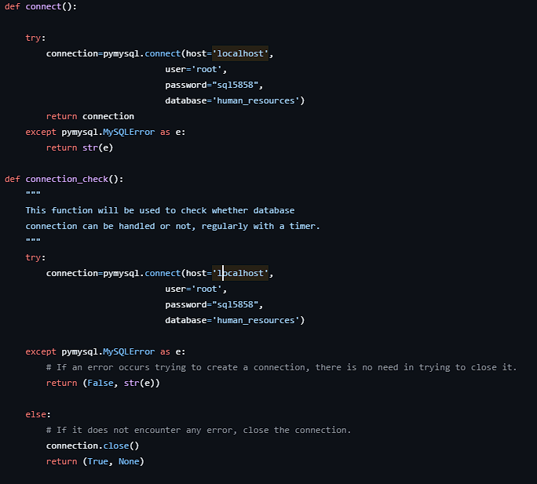

We used pymysql library to connect database and implementing functions in app.

**Parameters:**

Host= Specifies the database server's hostname.

User= The username used to connect to the database.

Password= The password associated with the username **root** to authenticate the connection.

Database= Specifies the name of the database.

If the connection is successful, the connection object is returned. This object allows you to interact with the database (e.g., execute queries, fetch results).

* 1. **Interface Design**  
     5.1 **User Interface Design**

The interface of the project has been developed in Python. We used PyQt6 GUI toolkit.

Specify the programming languages and tools used to create the interface (e.g., Java, C#, PHP, HTML, CSS, etc.).

* 1. **Interface Overview**

Provide screenshots of each interface page, explaining its purpose and functionality. ( Examples: Login Page, Product Management Page (e.g., Add Product, Delete Product), Customer Information Page, Navigation and Buttons, ect…)

* 1. **Appendices**
* Include all relevant code used for the project, organized by functionality (e.g., database schema, connectivity code, interface design scripts).

---------------------------------------------------------------------------------------------------------------

* 1. **System Testing and Validation**

**(No writing here—this section is for live demonstration!!)**

* After presenting all components, test the program in front of your classmates.
* Demonstrate functionalities like adding, deleting, and modifying records through the interface and confirm that the changes are reflected in the database.